|  |
| --- |
| ***Project Report:***  **Title: Hobbies For Postgraduate Students**    ***By***  ***Group 5*** *[Edison Chan, Helen Jerry, Oyuki Mar, Alessandro De Lima, Marcus Egbiki]*  **Student ID:** *(300370372, 300368611, 300373965, 300340437, 300368858)* |



**Introduction**

Due to high educational requirements, *Postgraduate students* are stressed by rigorous activities that require high mental focus. The theme of our website is aimed to provide an array of hobbies students can choose. Students are required fill a survey questionnaire and result is shown after submitting. The interest (Creating website) stems from strenuous semester courses in relation to availability of upcoming Summer activities.

**WebLayout**

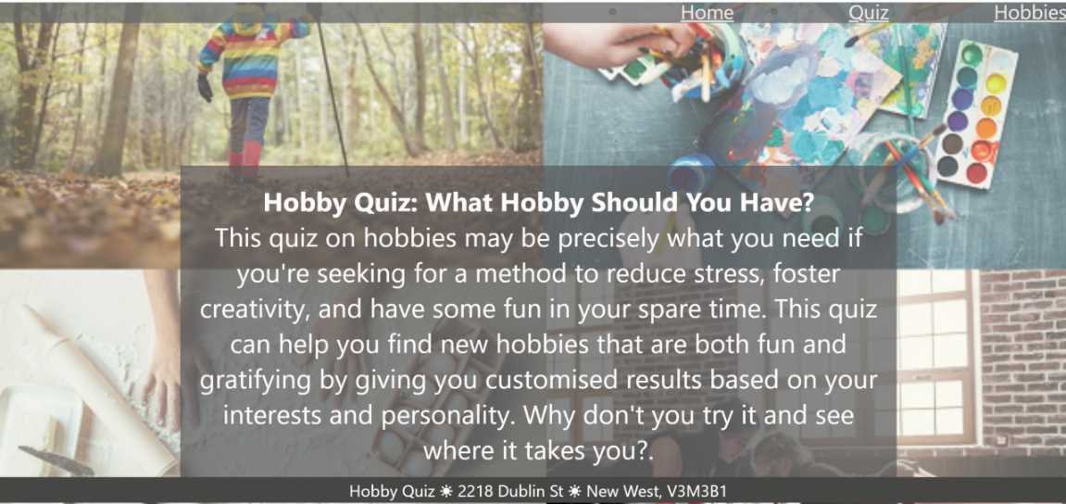

Table 1: General Layout

The framework of the website is designed for user engagement and consultation purposes. We implemented the use of the CSS Flex-Box to automatically resize the elements to the viewport. This was acted on by setting the position relative (body, wrapper, footer), absolute(image cover, overlay) and a float rightward of the web (Image).

In Content_Layout of the CSS, we justified the contents within the body, wrapper and footer. This will align within the viewport from its normal position: without causing a flaw in the web structure. For this to happen, a float:right was inputted to have the elements within the header adjacent to the right of the website in a vertical format.

Before that, a background image is needed to give style to the website created which can be unattractive if users of the web are unable to make a head of the in-text content. An overlay is added to transpose elements such as images, embedded videos etc.. in a solid color to caption these elements. This is implemented by setting the position as absolute. The motion behind this is to reduce visual impairment caused by the vibrant display of the background image.

We can state that the general wireframe of the layout is applied to the navigation links that directs users to the surveys, final results and suggestions. This is a design that allows web designers to expand on the current content by adding or removing (content).

**Website Organization**

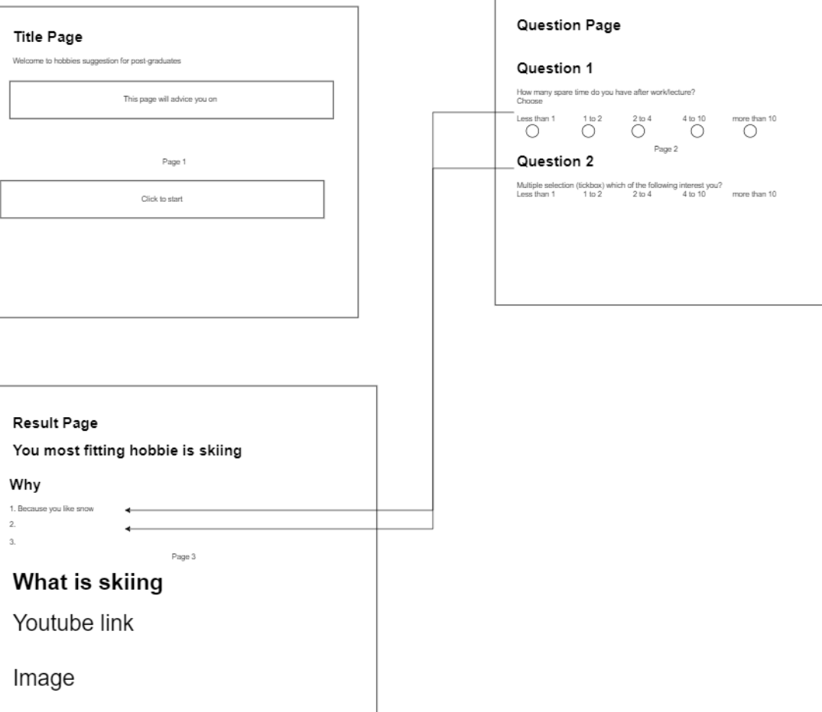

Table 2: Website Structure

The web structure of our project is segregated into 3 phases; *Home*, *Quiz*, and *Hobbies* as shown in table 2. The design of the web is targeted at activity(ies) users engaged in during the Summer. On the home page, we ask users of hobbies they may need whom are redirected to the quiz survey. Within the background, images such as hiking, painting, etc… to draws users curiosity and awareness of various hobbies they can engage in after a stressful Winter classes.

In the quiz section, 5 survey forms is generated for users to input the required information needed. These questions are either about activities they engage in or if there is an interest. All information provided, will lead to the generation of the final result.

The results of the quiz survey, displays an output of proposed hobbies that users could participate in; detailed summary and video links to Youtube that provides further information for user understanding. These video links go into depth of hobbies with caution of safety and the what not’s. Though, It’s a consultation approach; this is left to users decision to either engage or not.

**Content Declaration**

**Video**

* Manning, D. (2019, January 31). *Photography Basics in 10 minutes*. YouTube. Retrieved April 7, 2023, from https://youtube.com/watch?v=V7z7BAZdt2M&feature=share
* Douna, R. (2023, April 1). *Lots of movement & depth! abstract acrylic painting with fluid acrylics / 'wild waters'*. YouTube. Retrieved April 7, 2023, from https://youtube.com/watch?v=78PpEjCY3O8&feature=share
* Clarke, H. (2016, June 8). *How my hobby changed my life | Hailey Clarke | tedxkids@bc*. YouTube. Retrieved April 7, 2023, from https://youtube.com/watch?v=F7vOs-fI79A&feature=share
* Fuhrman, K. (2020, September 22). *How I made traveling my career after graduating college (and how you can too!)*. YouTube. Retrieved April 7, 2023, from https://youtube.com/watch?v=zNnPLRK1H6M&feature=share

**Image**

* Blog, W. (2013, November 27). *Wix editor: Static.wixstatic.com/media appears in URL of WIX Images: Help Center*. Wix.com. Retrieved April 7, 2023, from https://support.wix.com/en/article/wix-editor-staticwixstaticcommedia-appears-in-url-of-wix-images
* Lexica. (n.d.). Lexica. Lexica The Stable Diffusion search engine. Retrieved April 13, 2023, from https://lexica.art/

**Survey text form**

* Typeform, T. (n.d.). *Facebook survey template*. Typeform. Retrieved April 7, 2023, from https://www.typeform.com/templates/t/facebook-survey-template/
* NERIS Analytics Limited. (n.d.). Free personality test. 16Personalities. Retrieved April 13, 2023, from https://www.16personalities.com/free-personality-test

**Highlight (Bragging)**

The interactivity of our website as a survey is but a defining feature. It is a part to the various research carried out. The in-depth explanation of hobbies is the highlight of the website. It’s the core element of the website designed to grasp the users interest with detailed information assisted with supporting elements. These elements, Images and Videos, provide life suggestions to users mostly postgraduates with health assisted activities. With a strenuous academic semester, there is the need to keep fit mentally and physically.

As a commercial perspective, health care providers as hospital, gym etc.. can utilize this website and provide further recommendations to ailing members of the society that aren’t in top condition. It’s a website that health care providers can expand on in the future.

**Reference**

* W3Schools. (n.d.). CSS Forms. W3schools. Retrieved April 13, 2023, from https://www.w3schools.com/css/css_form.asp